Binary spits 🡪 true

Unpruned 🡪 false

Confidence factor 🡪 0.25

Minimal number of objects 🡪 2

Cross validation on training:

Cross validation on training set

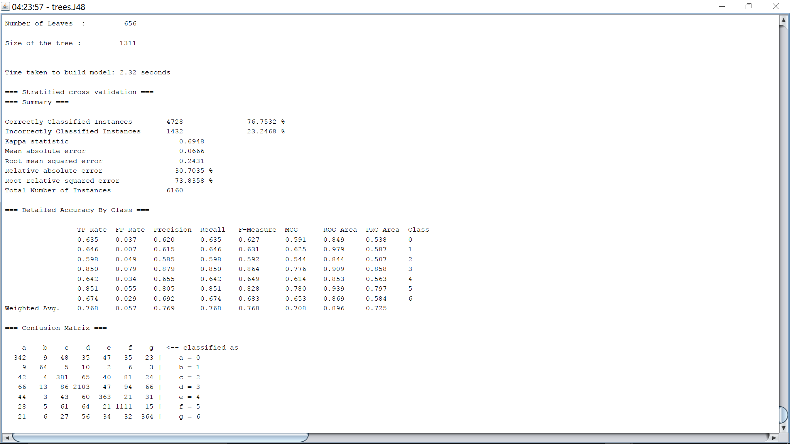

On training set

